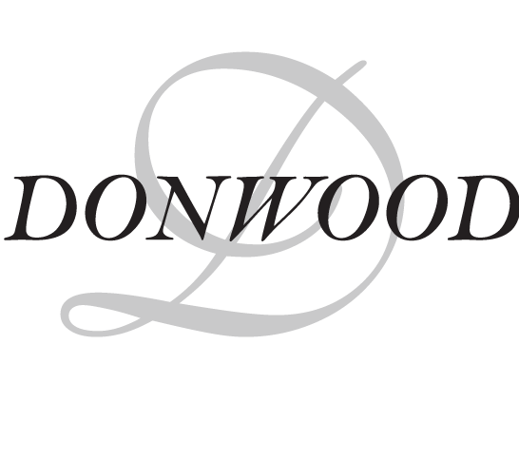
EMPLOYMENT OPPORTUNITY
Caring for Seniors with Dignity, Respect and Christian Values
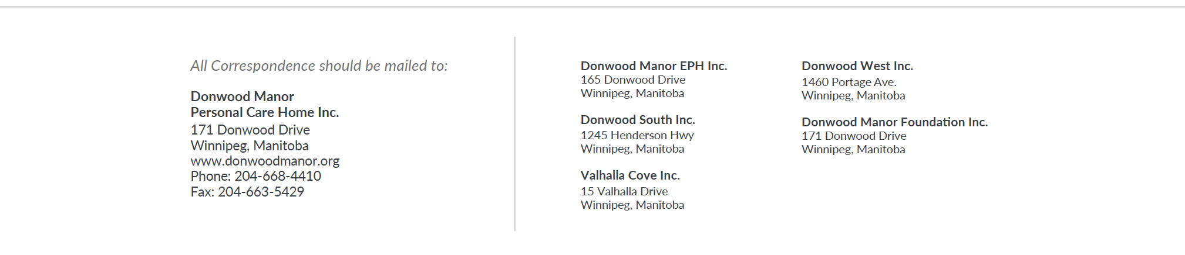  Position | Office Coordinator
Permanent/Term | Full time permanent (1.0 EFT)
Shifts | Monday to Friday, 7.5 hours per day
Donwood Manor PCH is looking for an Office Coordinator to serve as the first impression of the organization by providing a warm welcome in person and over the phone. This individual will provide support in various administrative tasks to different areas of the organization. They require a high degree of professionalism, enthusiasm, and attention to detail. In all activities, the Office Coordinator ensures that services are framed by the resident/tenant perspective to reflect Donwood’s mission of caring for seniors with respect, dignity and Christian values.

Qualifications:
- Post-secondary degree or diploma in Business Administration or related field;
- Previous experience in a healthcare setting in scheduling, administrative roles;
- Excellent interpersonal, oral, written and presentation skills;
- Ability to work in a fast-paced environment with frequent interruptions
- Proficient use of computers including Microsoft Office suite;
- Graphic design skills and website management an asset;
- Accuracy, organizational skills and ability to work with minimal supervision;
- Demonstrated ability to handle fluctuating workload and ability to prioritize;
- Knowledge and familiarity with the German Mennonite culture and community an asset;
- Familiarity of long-term care an asset

As a condition of employment, a current Criminal Record Certificate and an Adult Abuse Registry is required within three weeks of hire date. Applications should be submitted at reception to the attention of Human Resources or emailed to Career@donwoodmanor.org
Closing date: 0900 on Thursday, September 3, 2021
August 27, 2021

