EMPLOYMENT OPPORTUNITY
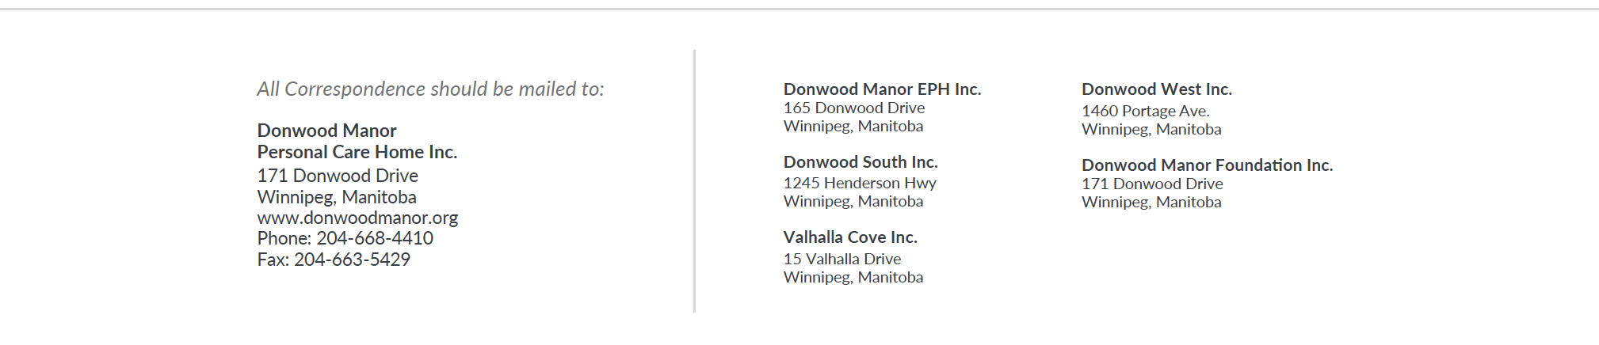
Position | Health Care Aide #5
Permanent/Term | Term
EFT | 0.69
Shifts | Day shifts
Start Date | To be determined

Qualifications:
- HCA Certificate from an approved College
- Strong communication skills
- Ability to establish positive working relationships
- Physically able to meet the demands of the job

As a condition of employment, a current Criminal Record Certificate and an Adult Abuse Registry is required within three weeks of hire date.

Applications should be submitted at reception to the attention of Human Resources or emailed to Career@donwoodmanor.org

Closing date: 0900 on Friday, November 19, 2021
Posted November 12, 2021

